A rare 2,000-year-old scroll about the early years of Buddhism is made public
Thư viện Quốc hội đã công bố một văn bản hiếm hoi 2.000 năm trước của Phật giáo và nó cung cấp một cái nhìn thoáng qua về lịch sử Phật giáo trong những năm hình thành.

By Allen Kim, CNN
Updated 0004 GMT (0804 HKT) July 30, 2019

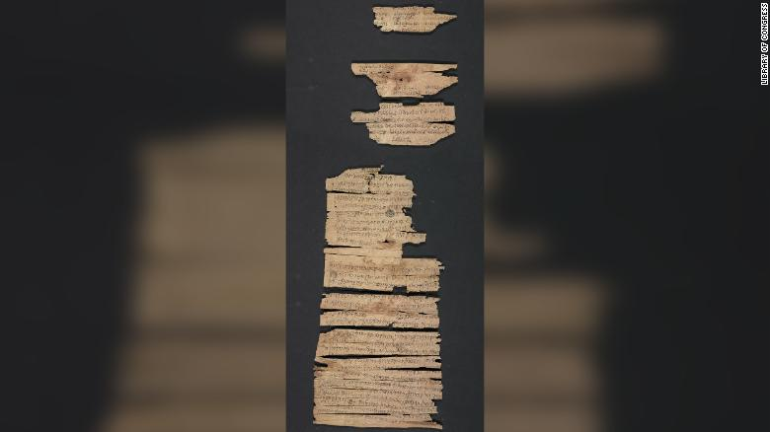
A portion of the Gandhara scroll from the Library of Congress

(máy dịch) (CNN) Thư viện Quốc hội đã công bố một văn bản hiếm hoi 2.000 năm trước của Phật giáo và nó cung cấp một cái nhìn thoáng qua về lịch sử Phật giáo trong những năm hình thành.
Cuộn sách có nguồn gốc ở Gandhara, một khu vực Phật giáo cổ ở miền bắc Afghanistan và Pakistan. Chỉ có vài trăm bản thảo Gandharan được các học giả trên toàn thế giới biết đến, và mỗi bản đều quan trọng để hiểu được sự phát triển ban đầu của văn học Phật giáo. Ví dụ, bằng cách sử dụng phân tích ngôn ngữ, các học giả nghiên cứu các bản thảo này để lập biểu đồ cho sự truyền bá của Phật giáo khắp châu Á.
Bản văn Gandhara thuật lại bởi Đức Phật Thích Ca Mâu Ni, nhà lãnh đạo tôn giáo còn được gọi là Siddhartha Gautama, và kể câu chuyện về 13 vị Phật đi trước Ngài, sự xuất hiện của chính Ngài và dự đoán về một vị Phật tương lai. Thông tin về mỗi vị Phật sống được bao lâu, tầng lớp xã hội mà mỗi vị Phật được sinh ra và thời gian giáo hoá bao lâu đều được ghi chép trong văn bản.
.
(CNN)The Library of Congress made public a rare 2,000-year-old text of early Buddhism on Monday, and it offers a glimpse into early Buddhist history during its formative years.
The scroll originated in Gandhara, an ancient Buddhist region in northern Afghanistan and Pakistan. Only a few hundred Gandharan manuscripts are known to scholars worldwide, and each is vital to understanding the early development of Buddhist literature. For instance, using linguistic analysis, scholars study these manuscripts to chart the spread of Buddhism throughout Asia.
The Gandhara text is narrated by Shakyamuni Buddha, the religious leader also known as Siddhartha Gautama, and tells the story of the 13 Buddhas who preceded him, his own emergence and the prediction of a future Buddha. Information on how long each Buddha lived, the social class they were born into and how long their teachings endured are all chronicled in the text.

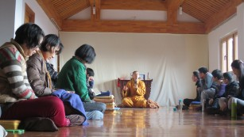
Buddhism Fast Facts
"This is a unique item because it is very old compared to similar manuscripts and, as such, it does bring us, historically speaking, relatively close to the lifetime of the Buddha," Jonathan Loar, reference librarian in the Asian Division at the Library of Congress, said in a statement.
The library's scroll retains nearly 80% of the original text, with only the beginning and end missing. Most other Gandharan scrolls known to scholars are more fragmentary.
"I wanted to find a way to share this incredibly unique item with the public," Loar told CNN. "The scroll is very well-preserved thanks to the work of the Library's conservators, but it is still incredibly fragile."
Purchased in 2003 from a private collector, the scroll is one of the most complicated and fragile pieces that the Library of Congress has ever treated. It took conservators several years to devise a treatment strategy, and they practiced unrolling techniques on dried-up cigars.
The treatment of the text would've never been possible if not for the unique conditions in which it was stored.
"One reason is that Gandharan scrolls, like the one at the Library of Congress, were typically buried in terra cotta jars and interred in a stupa, a dome-shaped structure often containing Buddhist texts or relics," Loar said. "Another reason is that the relatively high, arid climate of the Gandharan region helps preserve materials like manuscripts on birch bark."
Although the manuscript itself is too fragile for public display, by digitizing the text, the library is able to share this important piece of history with the public.

Library of Congress

MANUSCRIPT/MIXED MATERIAL Gandhara scroll.
EnlargeView 4 images in sequence.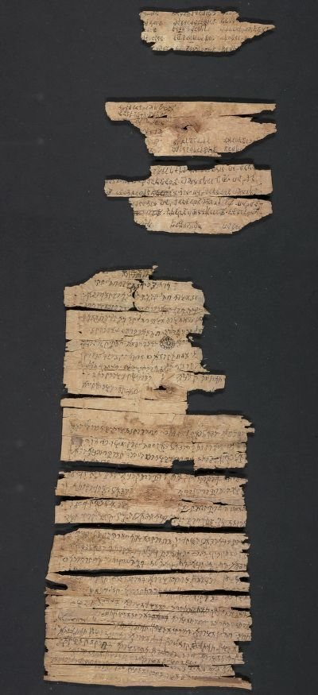
[ Digitized scroll: ]
Top of Form
Title
Gandhara scroll.

Summary
Contains information on the parallel lives of fifteen buddhas: Dīpaṅkara, Sarvābhibhū, Padmottara, Atyuccagāmin, Yaśottara, Śākyamuni [I], Tiṣya, Vipaśyin, Śikhin, Viśvabhū, Krakucchanda, Konākamuni, Kāśyapa, Śākyamuni [II] (also known as Siddhartha Gautama), and Maitreya. The scroll gives the buddhas' predictions of Śākyamuni's future coming as the Buddha; his four courses of training under the other buddhas; their lifespans; eons in which they lived; social class into which they were born; their assemblies of disciples; and duration of their teachings.
"The ancient kingdom of Gandhara (today's Afghanistan and Pakistan) is the source of the oldest Buddhist manuscripts in the world, as well as the oldest manuscripts from South Asia in existence. Acquired in 2003, the Library's Gandhara scroll roughly dates between the first century BCE and first century CE. Its language is Gandhari, a derivative of Sanskrit, and the script is called Kharoshthi. Scholars have informally called this scroll the Bahubuddha Sutra, or 'The Many Buddhas Sutra,' because it resembles a text with a similar name in Sanskrit. The scroll discusses the lives of fifteen buddhas. The text is narrated by Shakyamuni Buddha who gives very short biographies of thirteen buddhas who came before him, followed by his birth and emergence as Shakyamuni Buddha, and ending with the prediction of the future buddha, Maitreya. The biographies contain other information, such as how long each buddha lived, how each predicted the eventual appearance of Shakyamuni Buddha, what social class the buddha was born into, and how long his teachings endured"-- Provided by Library of Congress Asian Division staff.
Created / Published
[Gandhara] : [producer not identified], [approximately 1st century B.C.-approximately 1st century A.D.]
Subject Headings
- Buddhas--Early works to 1800
- Manuscripts, Kharoṣṭhi--Washington (D.C.)
- Manuscripts, Prakrit--Washington (D.C.)
Notes
- Title devised by cataloger.
- This scroll on birch bark originates from the ancient Buddhist region of Gandhara (Pakistan and Afghanistan today) and is one of the oldest known Buddhist manuscripts. It is written in the Gandhari Prakrit language in Kharoshthi script, which is read from top to bottom and right to left. Because the scroll contains writing on both sides, the scribe would have flipped the scroll vertically to continue writing on the verso.
- Manuscript is in six large fragments and approximately 130 smaller fragments; mostly complete with the very beginning and end missing. Fragments are stored flat in two custom clamshell boxes measuring 73.5 x 45 x 7.8 cm. One box contains the six large fragments and the other box contains the smaller fragments.
- Digitized images of this manuscript reflect the number, orientation, and order of fragments upon its unrolling and preservation in glass casing. In the image of the recto of the six large fragments, the three smallest fragments should be rotated 180 degrees to read the scroll.
- Described in: Krueger, Holly H. "Conservation of the Library of Congress' Gandhara Scroll: a Collaborative Process." The Book and Paper Group annual, 27 (2008).
- Described in: Salomon, Richard. "One Buddha, 15 Buddhas, 1,000 Buddhas.” Recorded November 15, 2018 at the Library of Congress. Running time: 75 minutes.

Medium
1 scroll.
Call Number/Physical Location
BQ4670 .G36
Library of Congress Control Number
2018305008
Access Advisory
Restricted access; material extremely fragile; please use online digital image.
Language
Prakrit Languages
Online Format
image
Description
Contains information on the parallel lives of fifteen buddhas: Dīpaṅkara, Sarvābhibhū, Padmottara, Atyuccagāmin, Yaśottara, Śākyamuni [I], Tiṣya, Vipaśyin, Śikhin, Viśvabhū, Krakucchanda, Konākamuni, Kāśyapa, Śākyamuni [II] (also known as Siddhartha Gautama), and Maitreya. The scroll gives the buddhas' predictions of Śākyamuni's future coming as the Buddha; his four courses of training under the other buddhas; their lifespans; eons in which they lived; social class into which they were born; their assemblies of disciples; and duration of their teachings. "The ancient kingdom of Gandhara (today's Afghanistan and Pakistan) is the source of the oldest Buddhist manuscripts in the world, as well as the oldest manuscripts from South Asia in existence. Acquired in 2003, the Library's Gandhara scroll roughly dates between the first century BCE and first century CE. Its language is Gandhari, a derivative of Sanskrit, and the script is called Kharoshthi. Scholars have informally called this scroll the Bahubuddha Sutra, or 'The Many Buddhas Sutra,' because it resembles a text with a similar name in Sanskrit. The scroll discusses the lives of fifteen buddhas. The text is narrated by Shakyamuni Buddha who gives very short biographies of thirteen buddhas who came before him, followed by his birth and emergence as Shakyamuni Buddha, and ending with the prediction of the future buddha, Maitreya. The biographies contain other information, such as how long each buddha lived, how each predicted the eventual appearance of Shakyamuni Buddha, what social class the buddha was born into, and how long his teachings endured"-- Provided by Library of Congress Asian Division staff.
LCCN Permalink
https://lccn.loc.gov/2018305008
Additional Metadata Formats
MARCXML Record
MODS Record
Dublin Core Record
IIIF Presentation Manifest
Manifest (JSON/LD)

Part of
- Asian Division (7,733)
- Library of Congress Online Catalog (1,031,391)

Format
- Manuscript/Mixed Material

Location
- Washington D.C.

Language
- Prakrit Languages

Subjects
- Buddhas
- Early Works to 1800
- Manuscripts, Kharoṣṭhi
- Manuscripts, Prakrit
- Washington (D.C.)

Featured in
- Library of Congress Blog
- Now Online! The Gandhara Scroll, a Rare 2,000-Year-Old Text of Early Buddhism

Related Items
- Conservation description from Book and Paper Group annual:
- Webcast video of "One Buddha, 15 Buddhas, 1,000 Buddhas":

Rights & Access

Cite This Item

More Manuscripts/Mixed Material like this

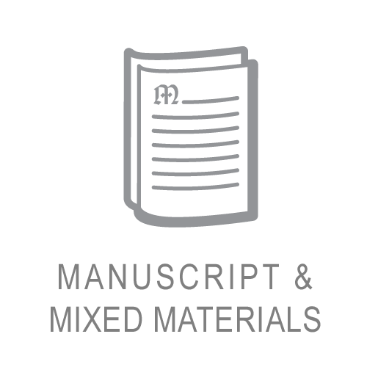
MANUSCRIPT/MIXED MATERIAL
Kashf al-qināʻ fī waḍʻ al-arbāʻ min al-jihat al-sitt fī ʻilm al-falak.
كشف القناع في وضع الأرباع من الجهة الست في علم الفلك.
MANUSCRIPT/MIXED MATERIAL
Kitāb qaṭr al-sayl fī amr al-khayl /
كتاب قطر السيل في أمر الخيل /
MANUSCRIPT/MIXED MATERIAL
Kitāb mafātīḥ al-raḥmah wa-asrār al-ḥikmah.
كتاب مفاتيح الرحمة و أسرار الحكمة. | Mafātīḥ al-ḥikmah.
MANUSCRIPT/MIXED MATERIAL
Jāmiʻ al-qawāʻid fī al-misāḥah.
جامع القواعد في المساحة. | Fann al-thālith min kitāb jāmiʻ al-qawāʻid fī ʻilm al-misāhah
MANUSCRIPT/MIXED MATERIAL
Kitāb qurrat al-ʻayn fī tasyīr al-nayyirayn /
كتاب قرة العين في تسيير النيرين / | Qurrat al-ʻayn bi-tasyīr al-nayyirayn

You might also like

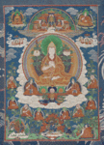
PHOTO, PRINT, DRAWING
Thangka of Tsong-kha-pa Blo-bzang-grags-pa.
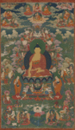
PHOTO, PRINT, DRAWING
Dpag bsam ʾkhri shing.
Mdzad brgya Dpag bsam ʾkhri śin. | Dpag bsam ʾkhri śin
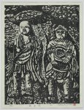

PHOTO, PRINT, DRAWING
Buddha on the rock wall
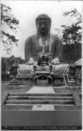
PHOTO, PRINT, DRAWING
Great bronze statue of Buddha, Kamakura, Japan
PHOTO, PRINT, DRAWING
Travel views of Japan and Korea
- Congress.gov
- United States Copyright Office

